**SE Deliverable III**

**Team Ultron – E Health Care**

ADMIN MODULE :

1. Admin has a username and password.

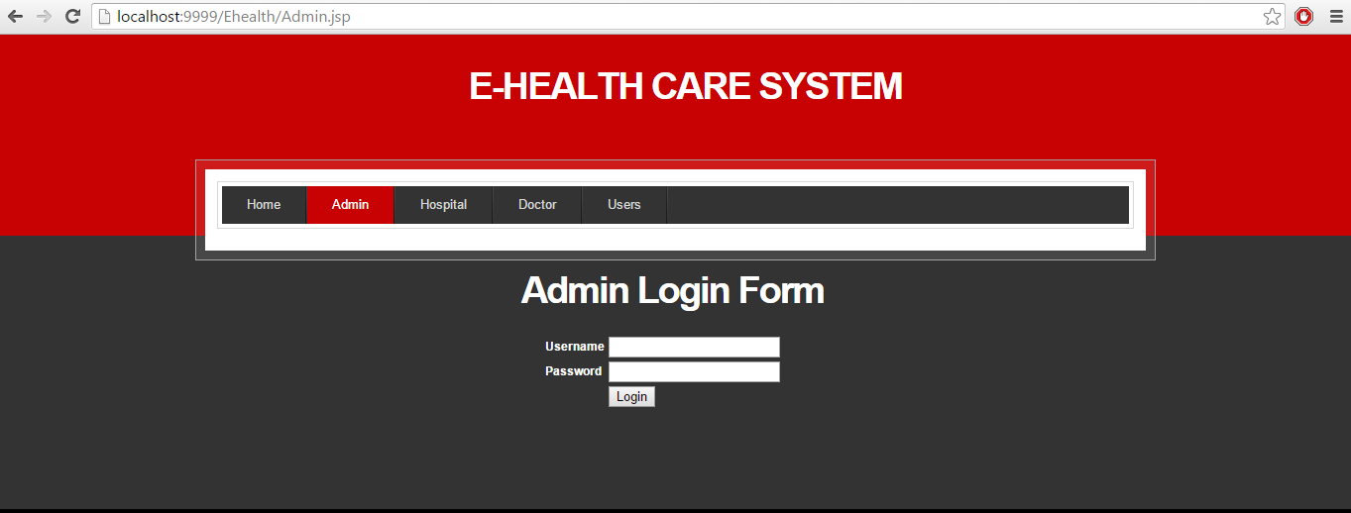

Validation :

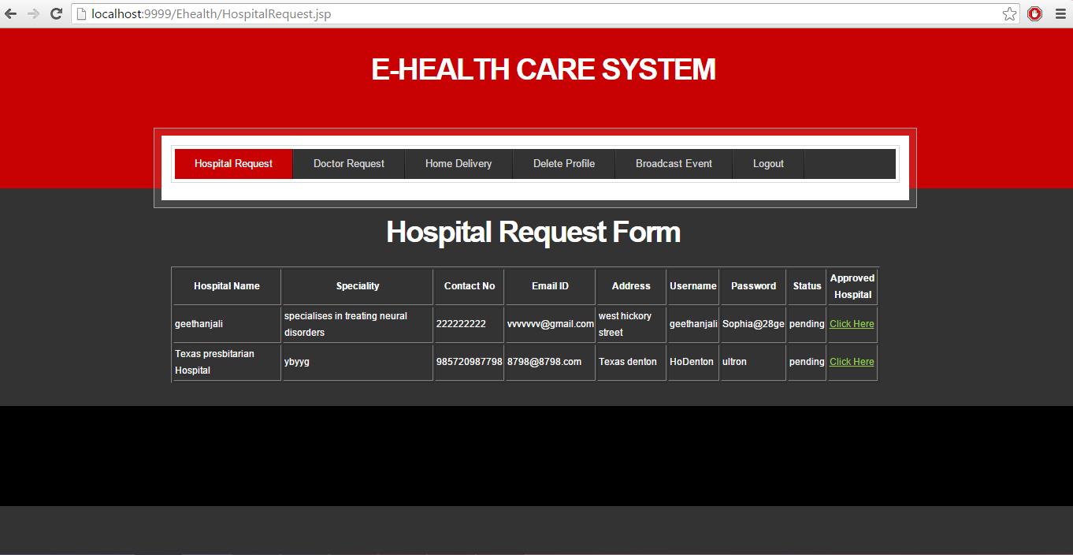

Admin can view the hospitals that have pending requests. Admin accepts the request

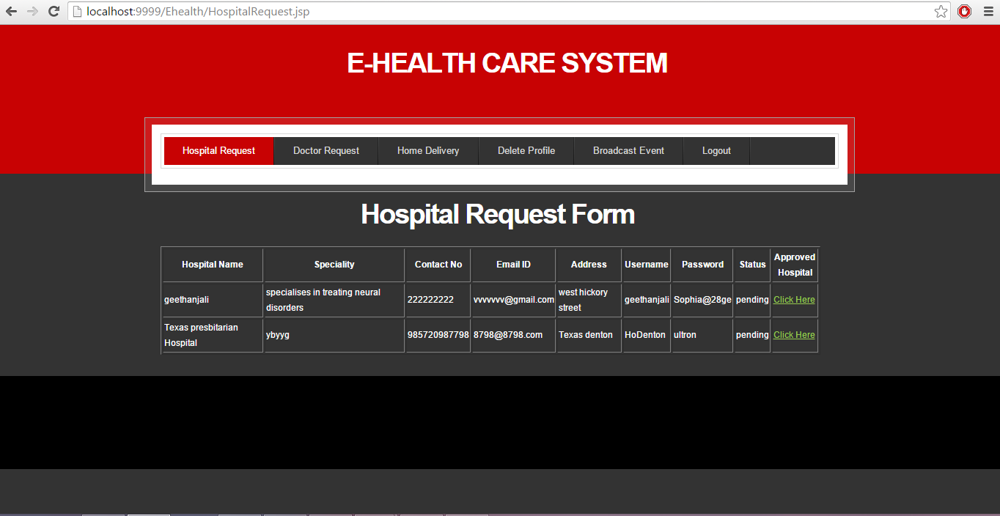

Admin can view the doctor requests :

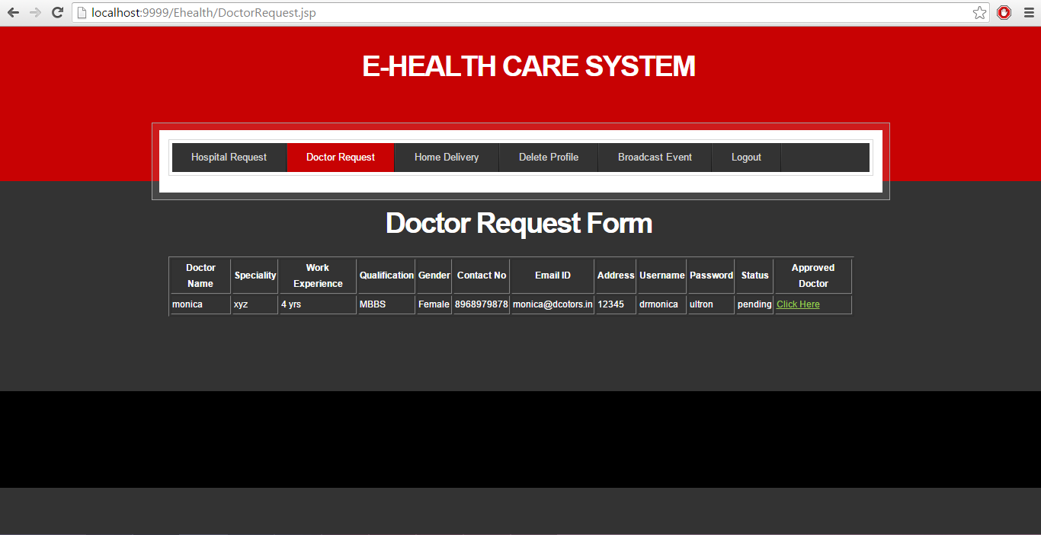

Validation :

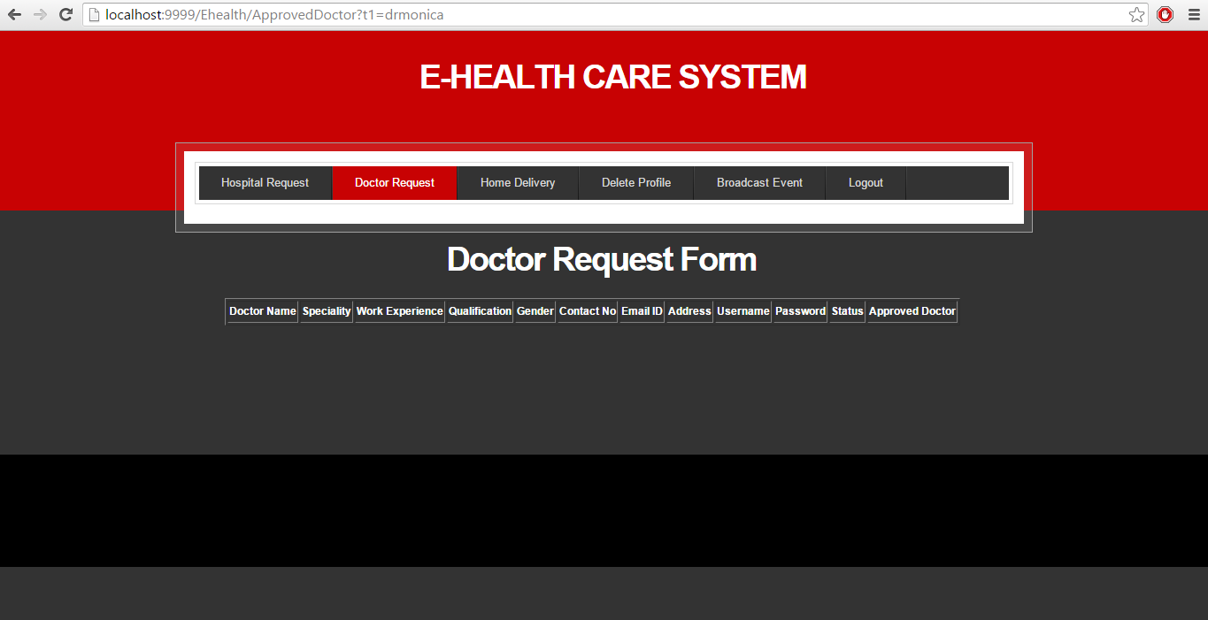

Admin can delete the profiles of users and doctors :

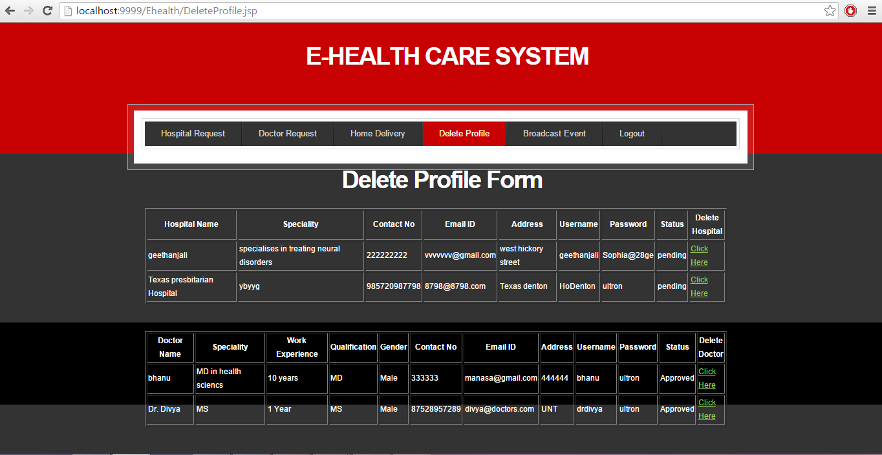

Admin can add any events related to the E-healthcare system.

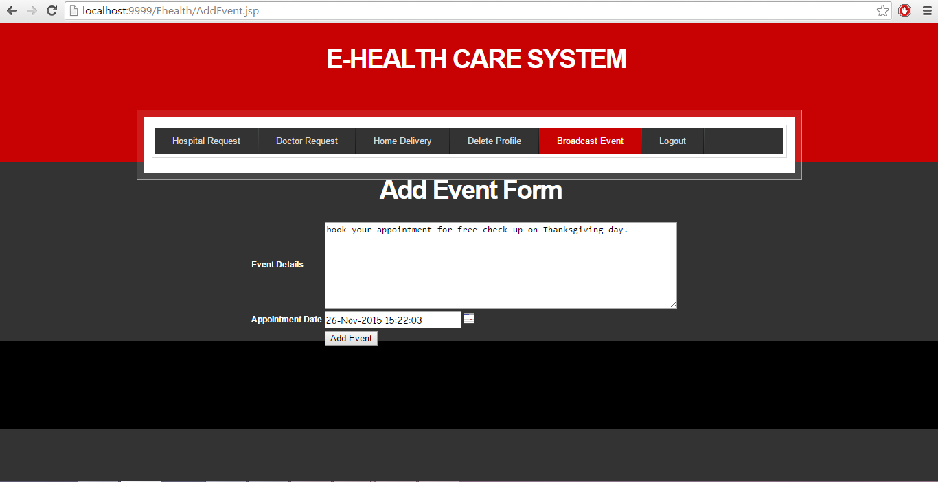

USER MODULE :

User has to provide his details for getting registered in to the E-healthcare system.

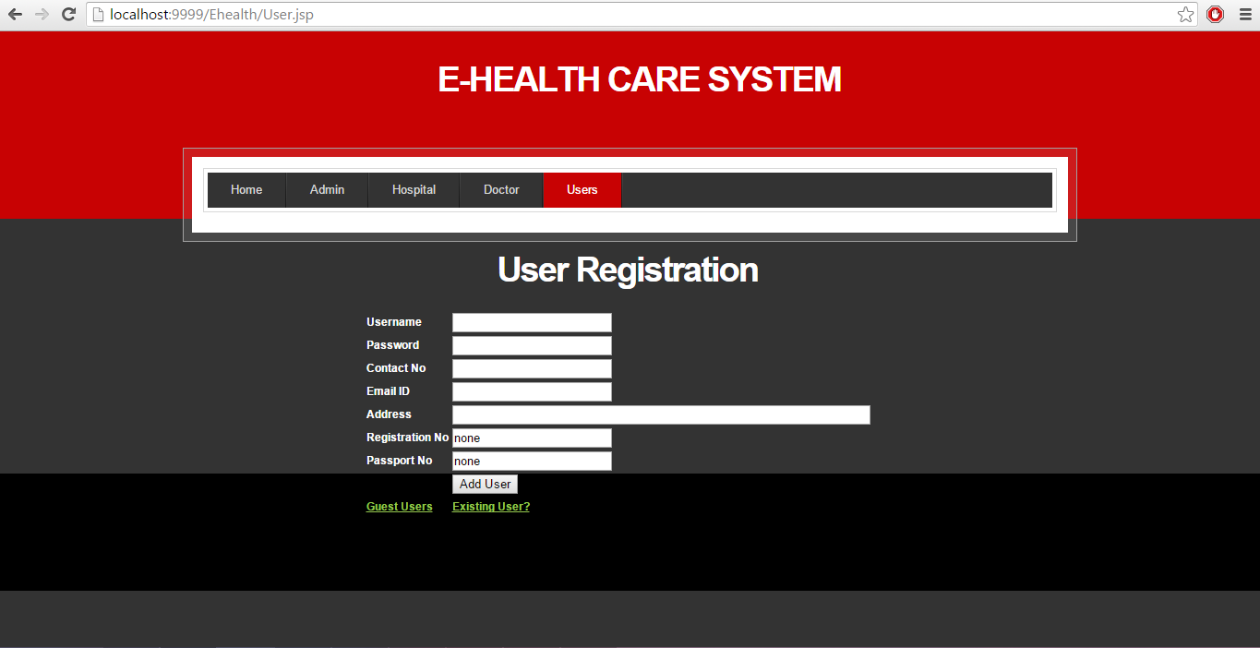

GUEST USER :

Guest user has the ability to view the events of the E-healthcare system and the doctors who are available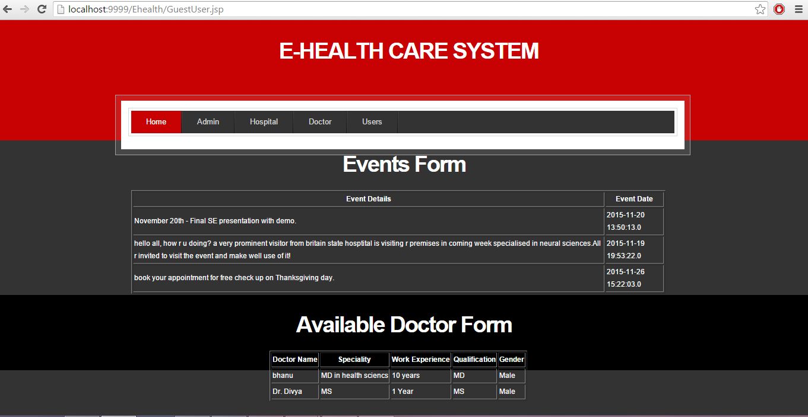

REGISTERD USER :

Registered is a type of user who signs up without providing the registration number :

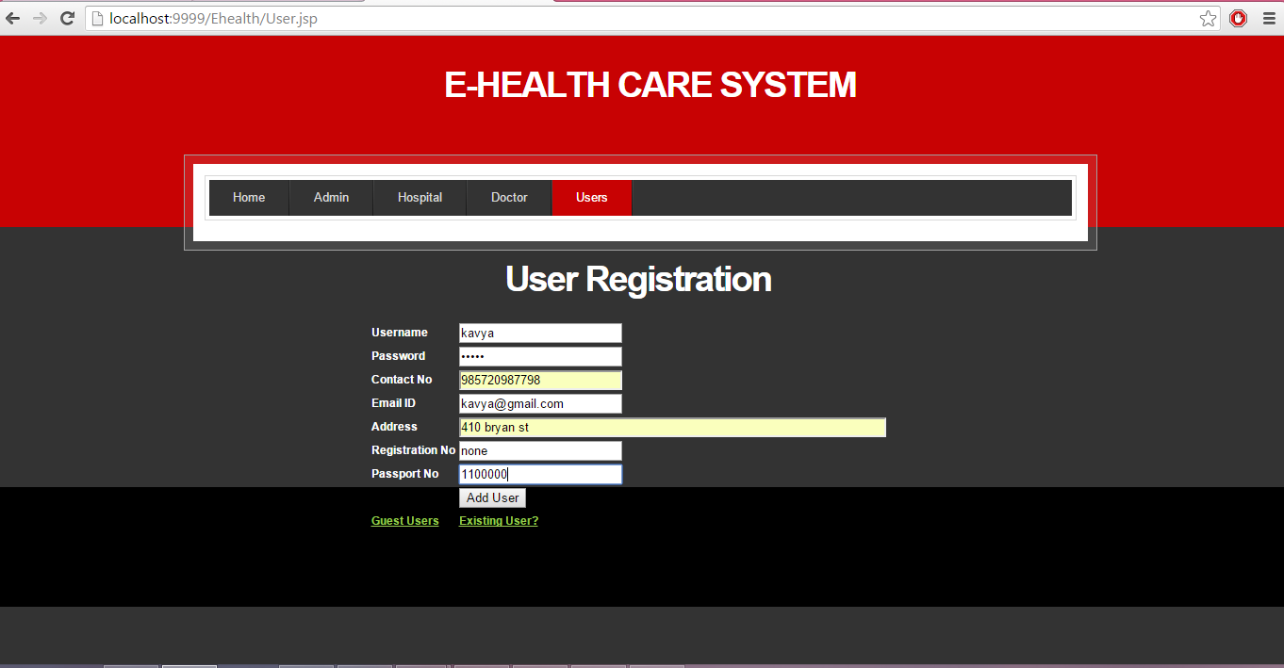

Validation :

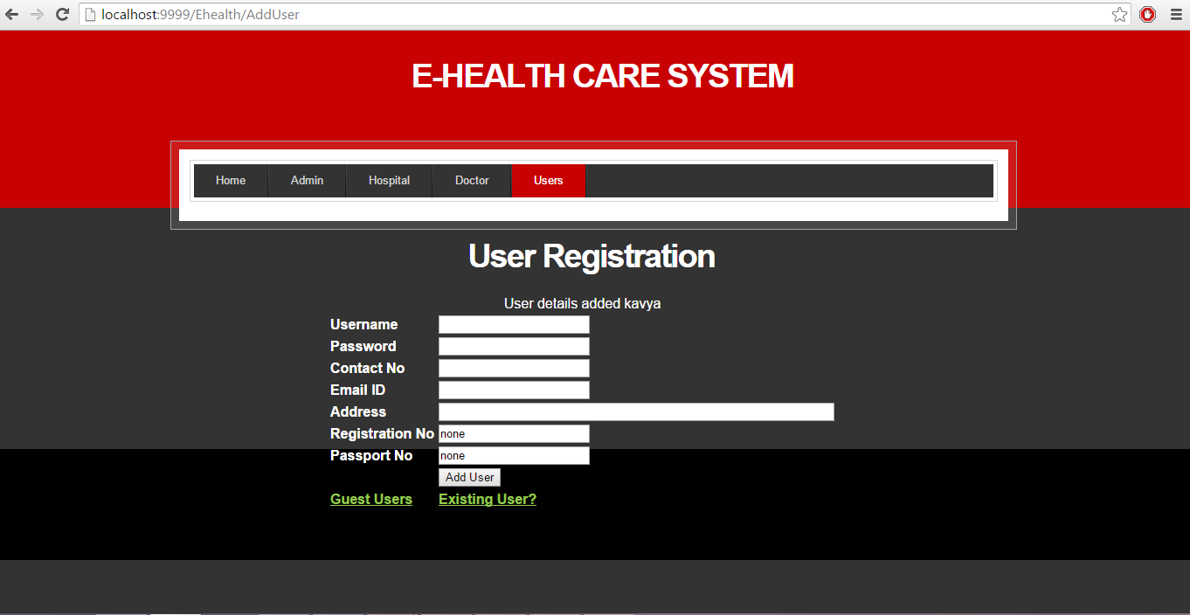

Registered user can view the doctors available in the E-healthcare system :

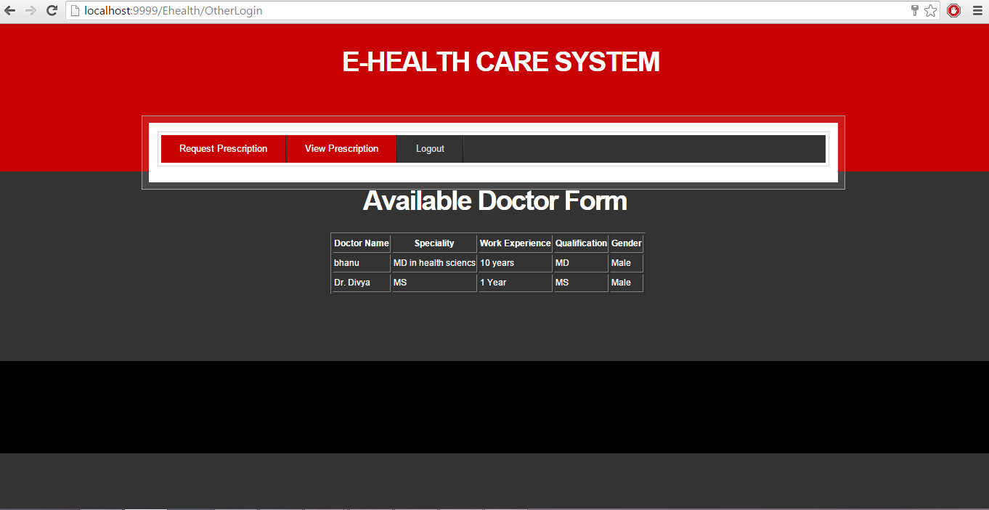

Registered user can request prescription from the doctor :

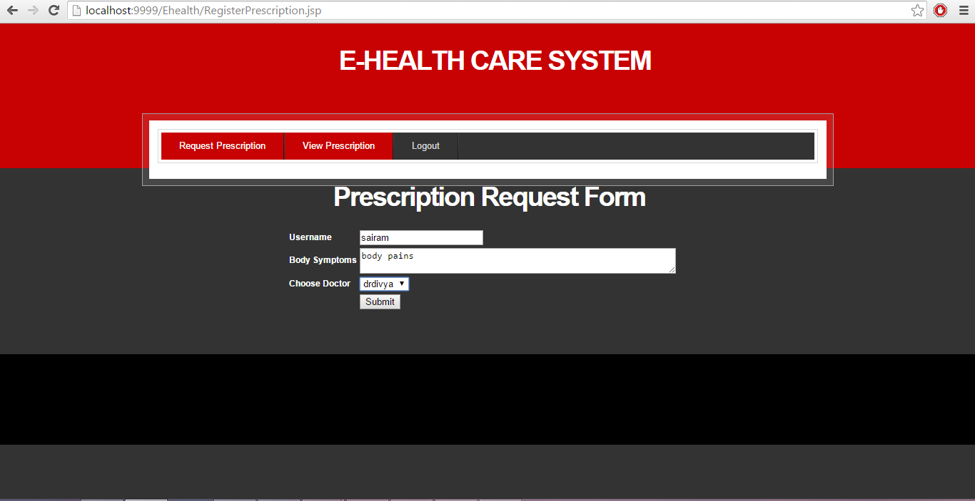

Confirmation :

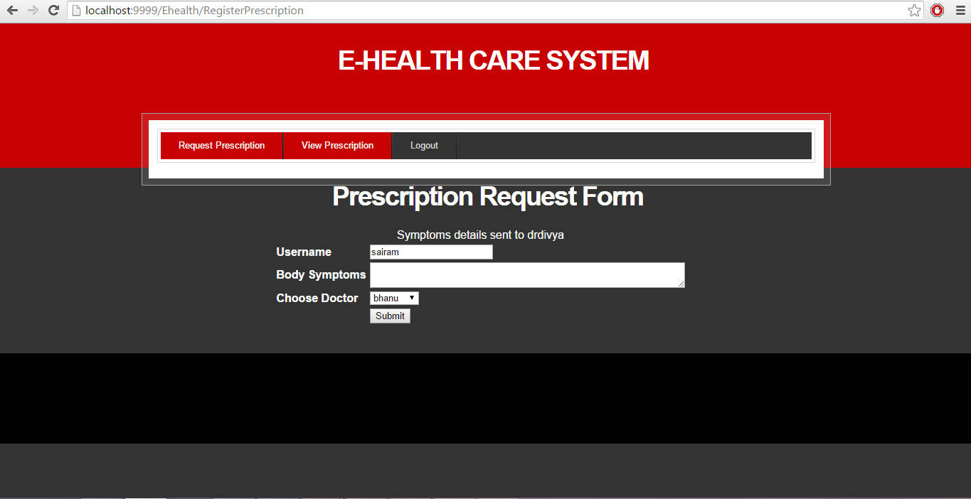

Registered user can view the prescription suggested by doctor on that particular date and time:

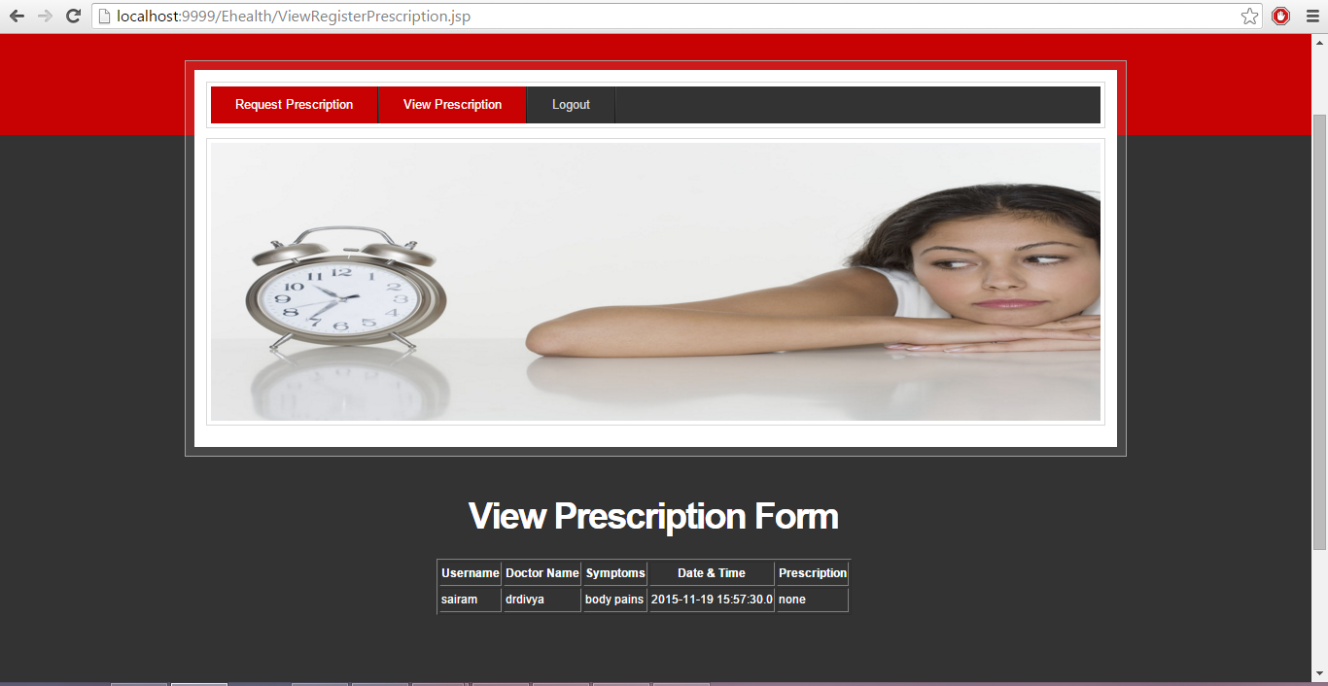

MEMBER USER :

Member user is the user who can register by providing his registration number :

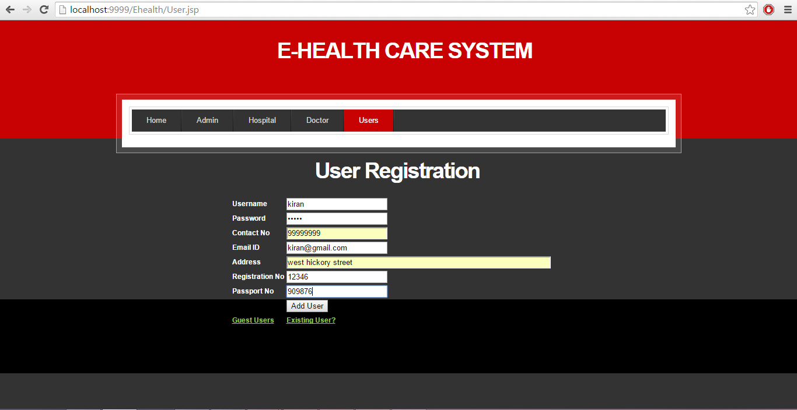

Validation :

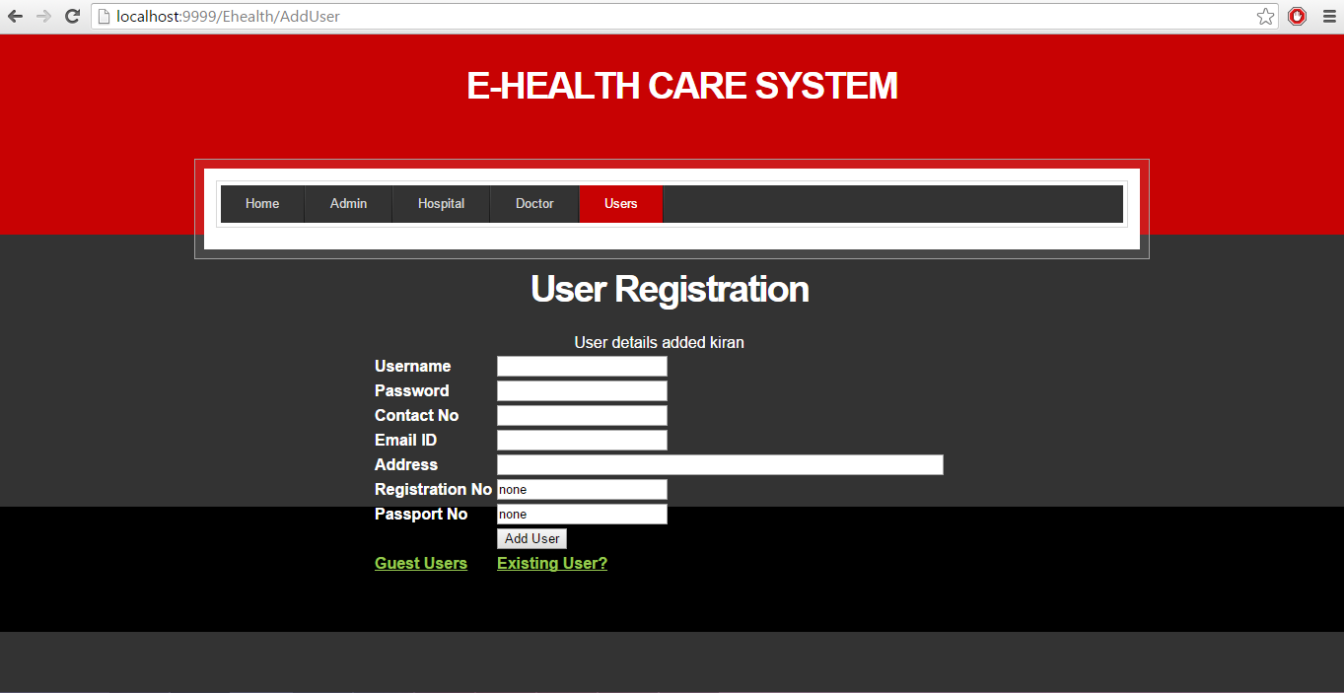

Member user can view the available doctors :

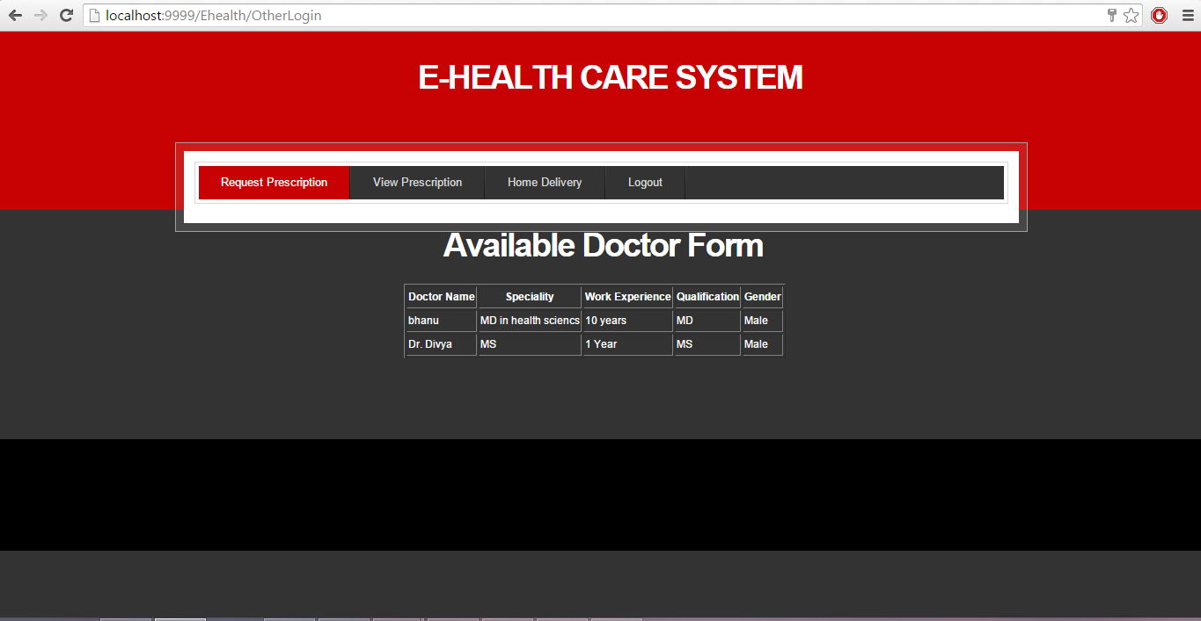

Member user can request for prescription :

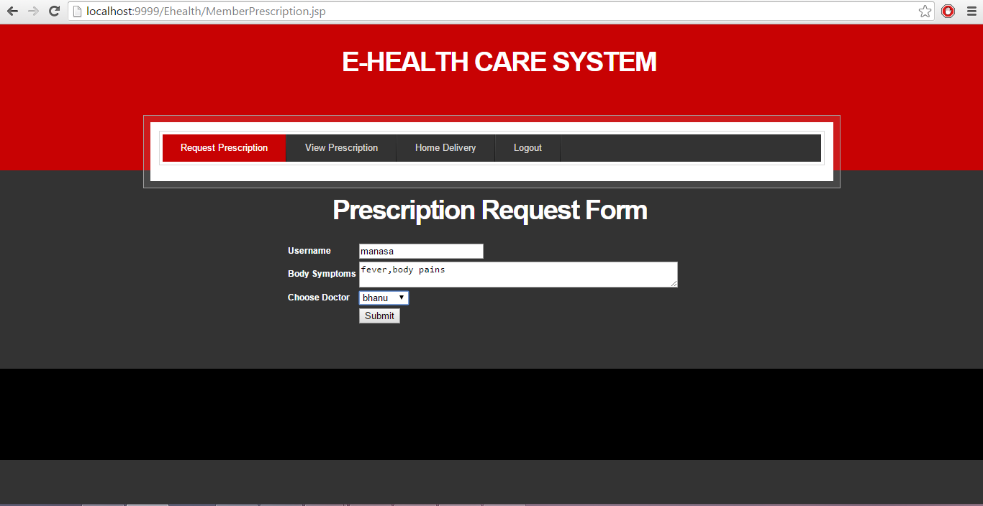

Validation :

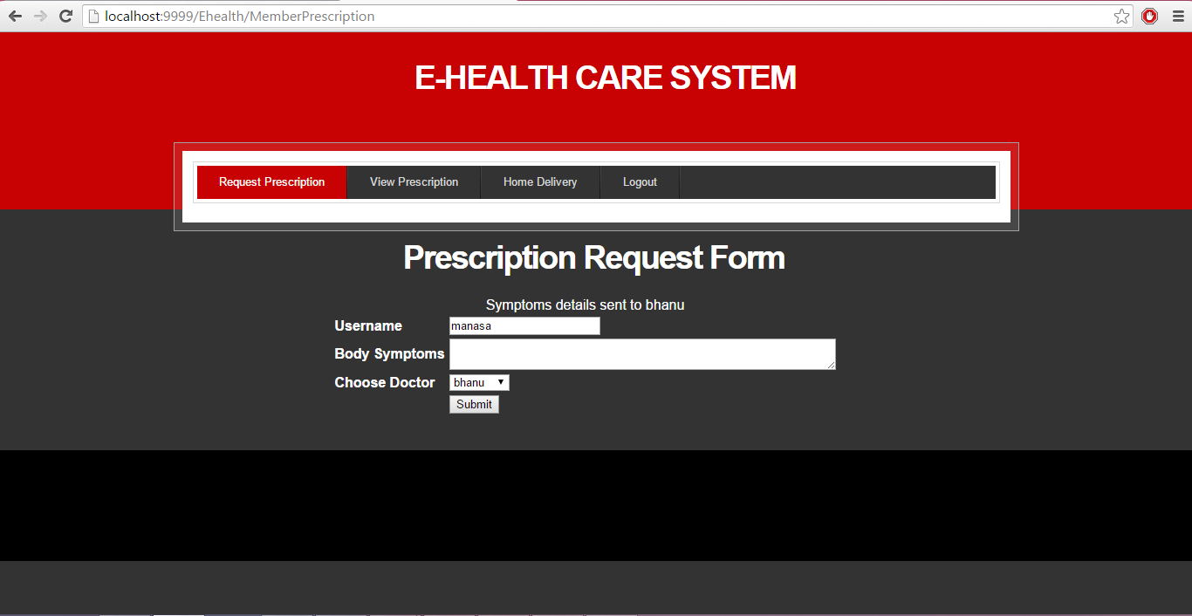

Member user can view the prescription :

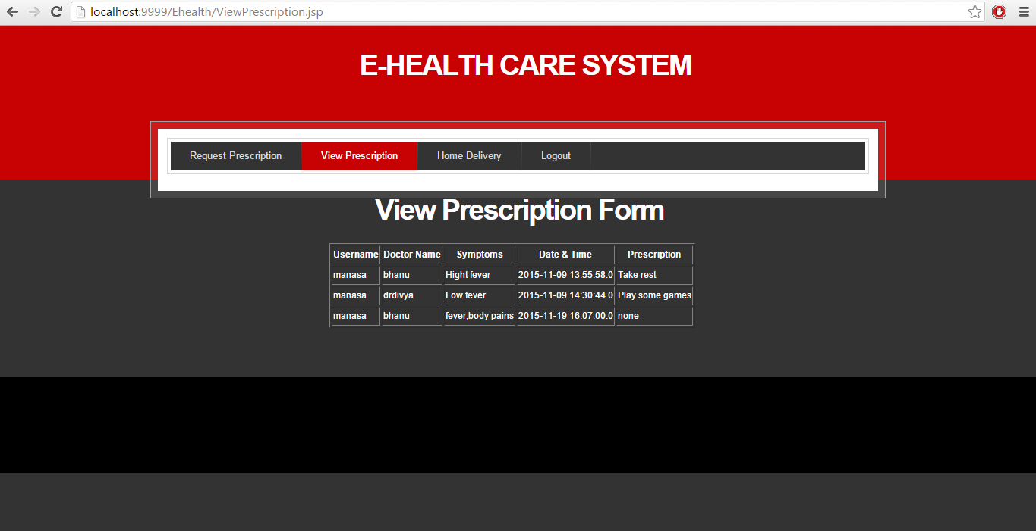

All the medical history of the patient is stored in the view prescription :



Member user has the ability to order medicines from the pharmacy through home delivery :

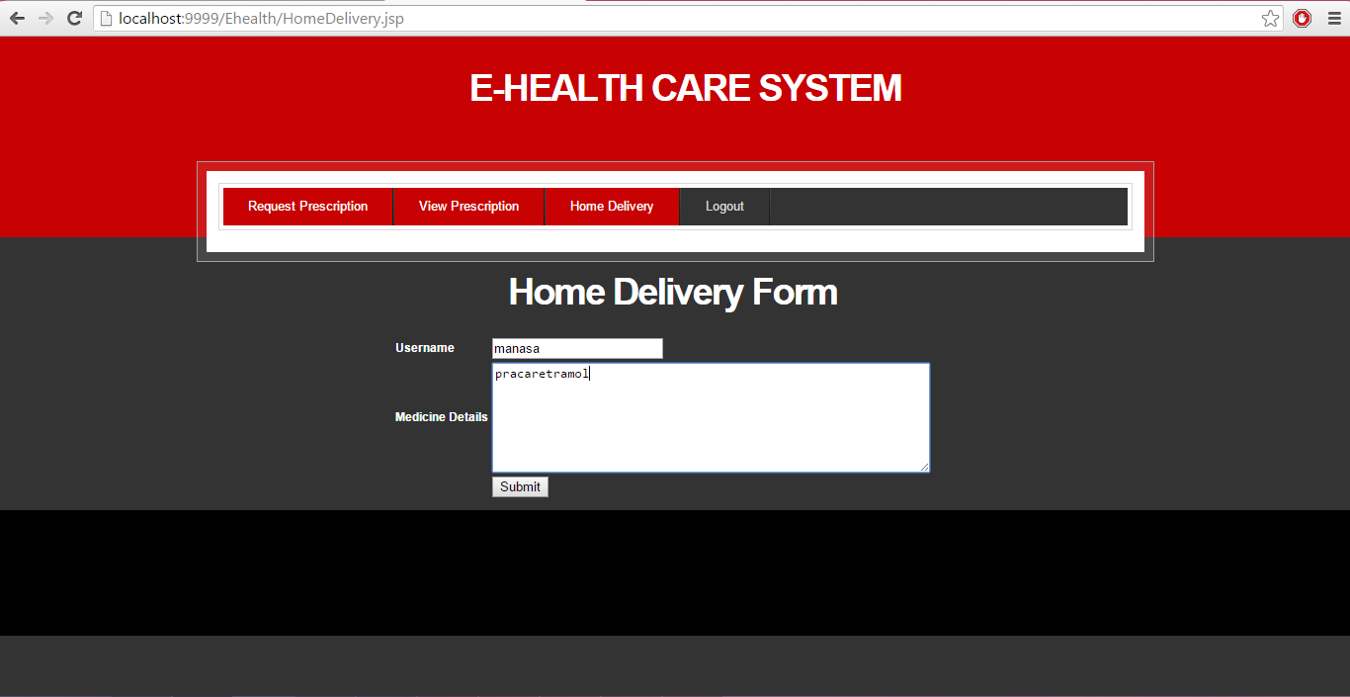

Validation :

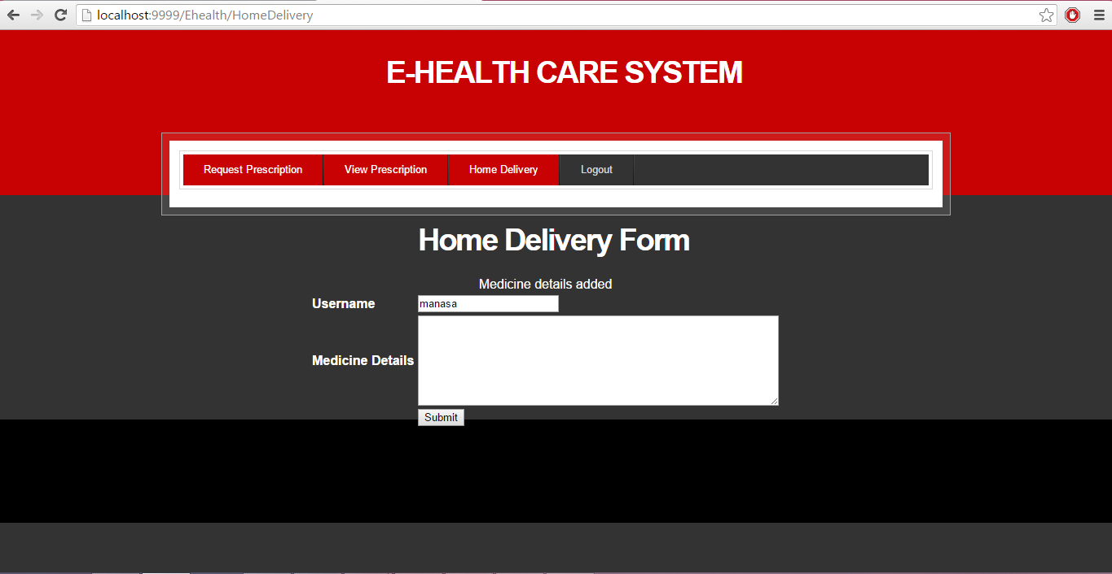

DOCTOR MODULE :

doctor has to fill the registration form to sign up to register with the E-healthcare system :

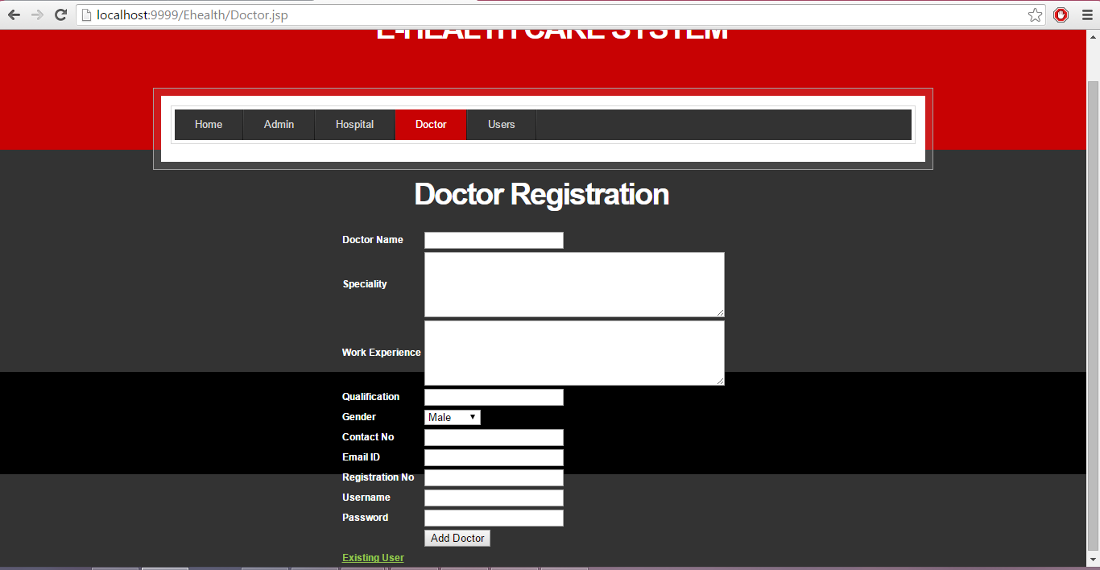

Validation :

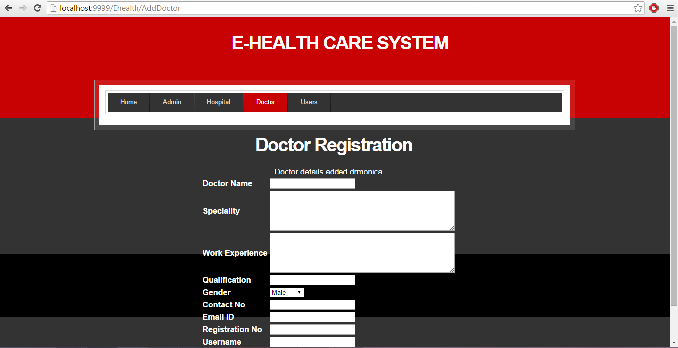

Doctor can view the approval from the admin :

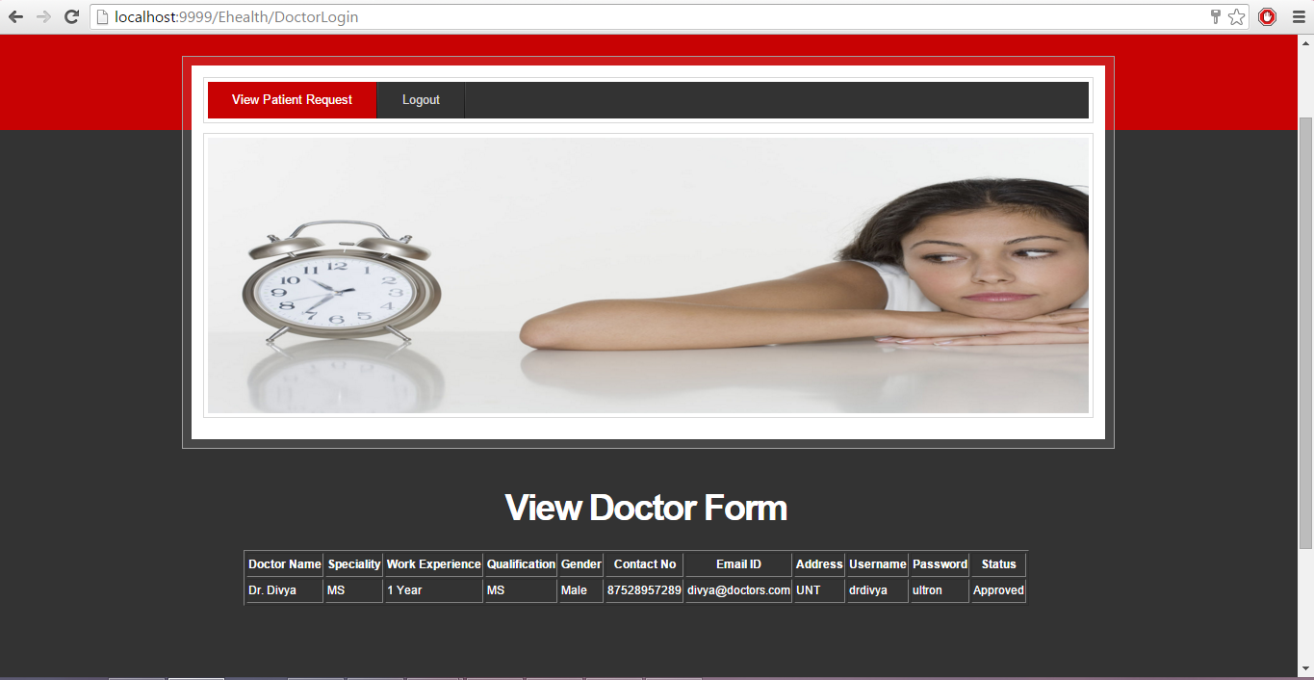

Doctor can select his patients for whom he has to provide prescription :

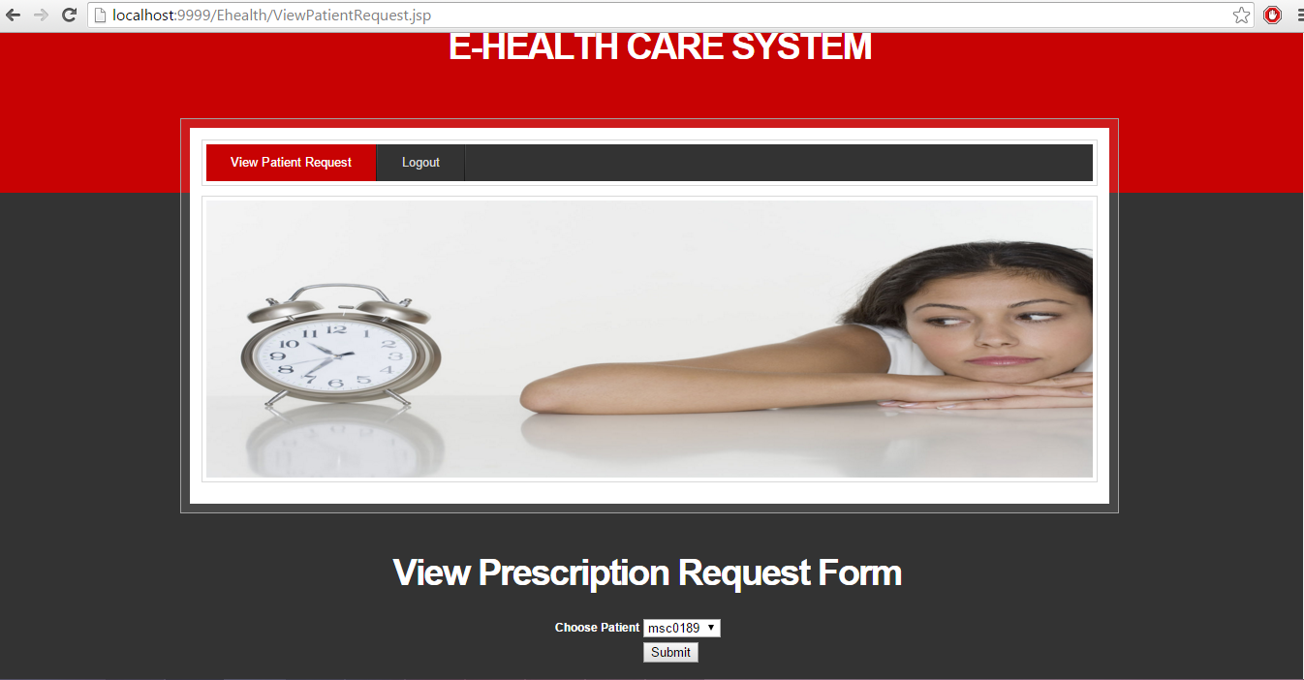

Doctor can give prescription to the patients by looking at their symptoms :

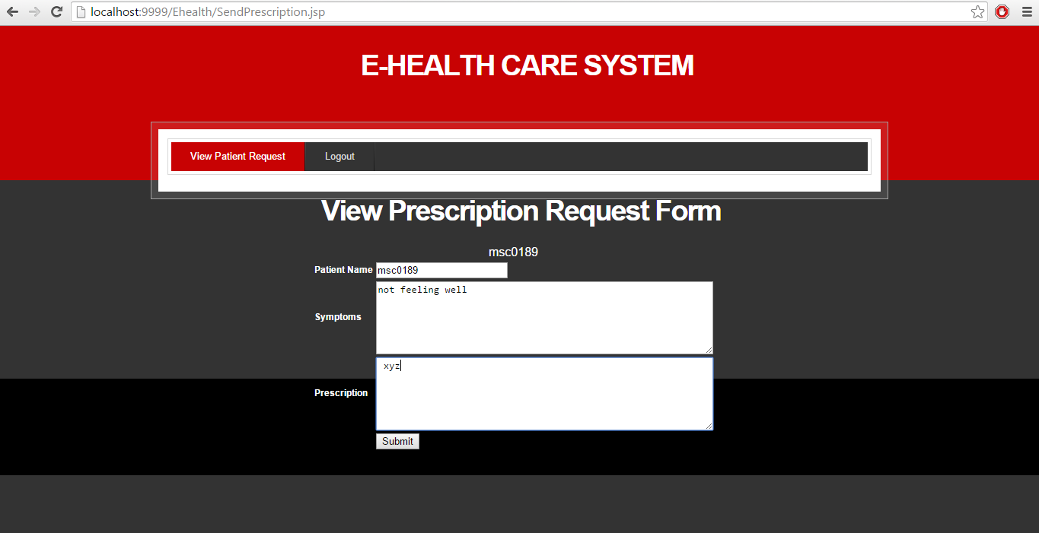

Validation :

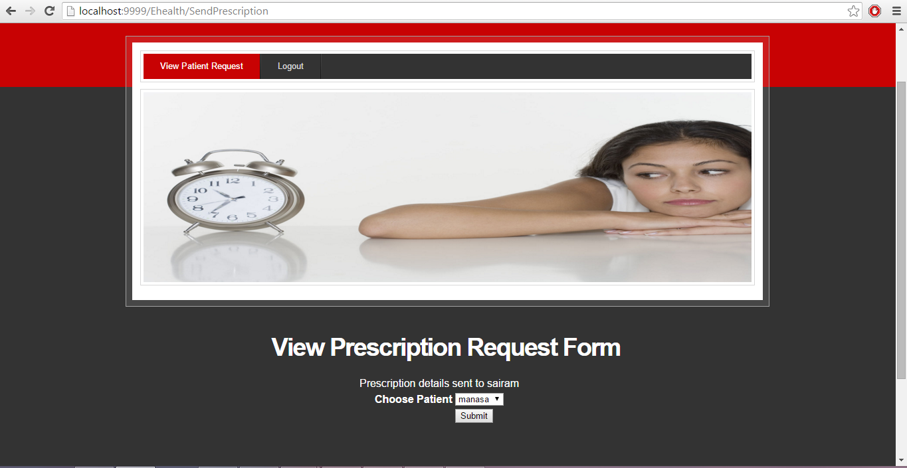

HOSPITAL MODULE :

The hospital has to register with E-healthcare system.

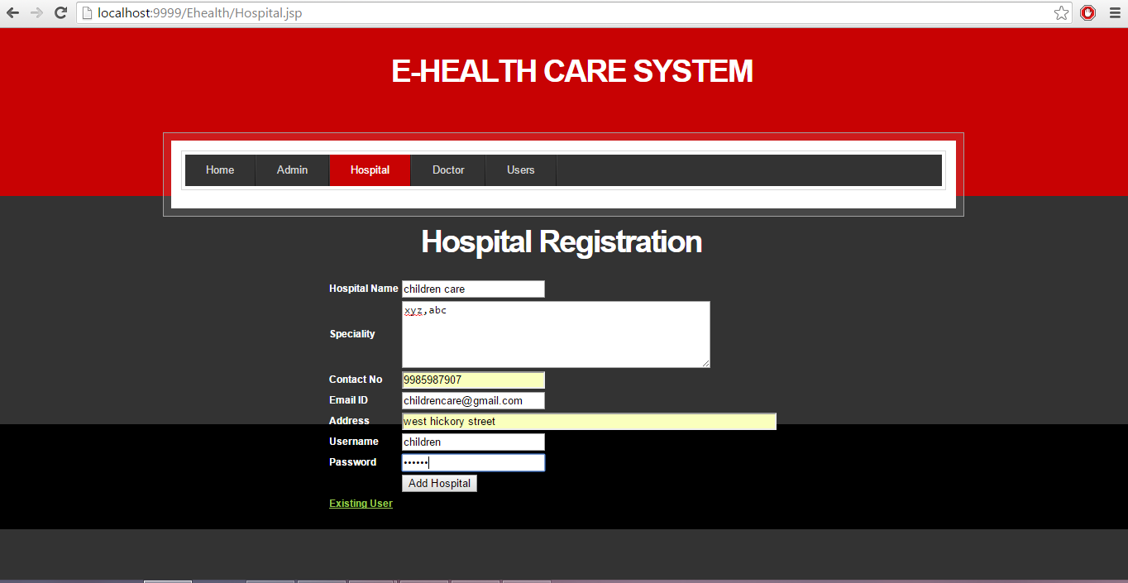

Validation :

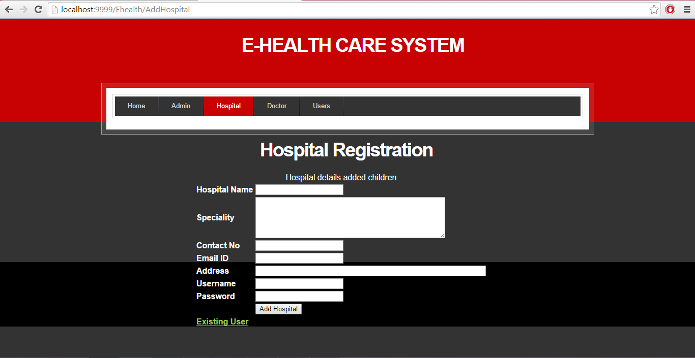

Hospital login form :

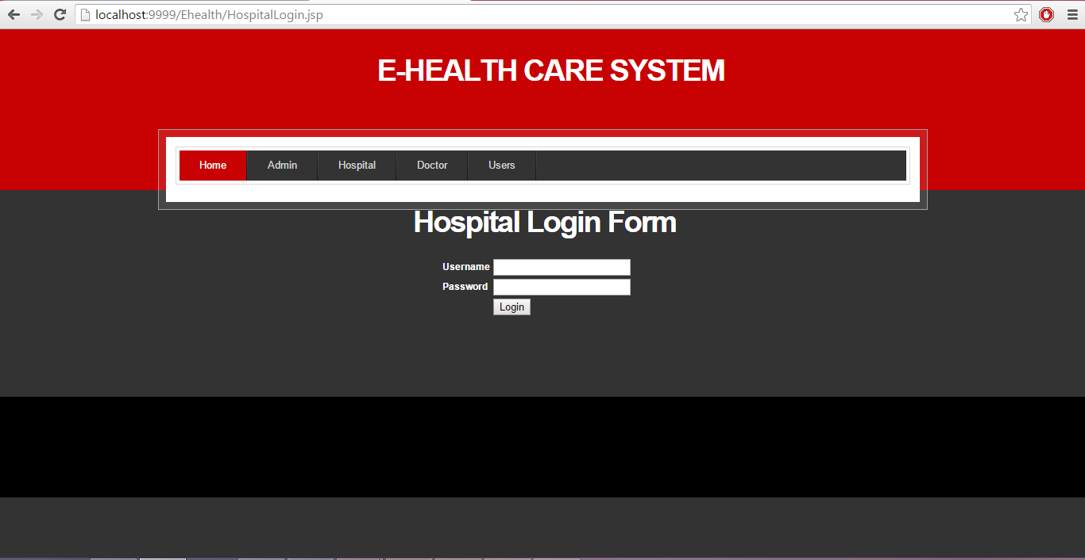

Validation :

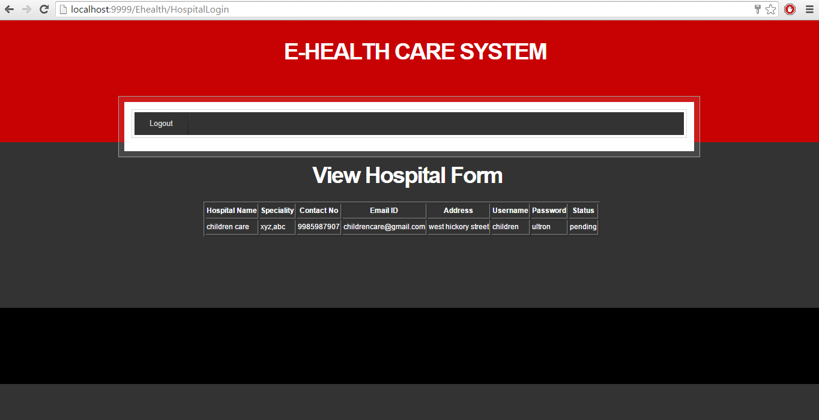

|  |  |  |
| --- | --- | --- |
|  | **User Name** | **Password** |
| **Admin** | **Admin** | **admin** |
| **Member User** | **manasa** | **ultron** |
| **Registered User** | **sairam** | **ultron** |
| **Doctor** | **Drdivya** | **ultron** |

**\* All small letters**

**Software’s Used:**

1. TOMACT 6.0

2. MY SQL

**Steps to run:**

1. Download Tomcat 6.0 or later version

2. Install/deploy the Tomcat folder in your local drive.  
 Example: C:\Tomcat 6.0

3. Merge or put the code in the “webapps” folder of Tomcat folder.  
 C:\Tomcat 6.0\webapps\Ehealth

4. Now go to any web browser like Google chrome and invoke the project

http://localhost:portnumber/Ehealth/  
 http://localhost:9999/Ehealth/

5. The above link will open the homepage of the E-healthcare system.

We have chosen JUnit testing for our code.

The process we tried to implement Junit for our code is.

1. We converted the normal web project to maven project.
2. Jetty (HTTP web server) was used to deploy the code.
3. In the pom.xml, jetty, mortbay, junit dependencies were added.
4. We have written some Junit test cases to test the source code.

But, we ended up having manual testing with well-written test cases and status report after execution.

Sample Junit

import junit.framework.TestCase;

import org.apache.jasper.servlet.JspServlet;

import org.mortbay.jetty.testing.HttpTester;

import org.mortbay.jetty.testing.ServletTester;

public class HelloWorldJspTest extends TestCase {

ServletTester tester = new ServletTester();

HttpTester request = new HttpTester();

HttpTester response = new HttpTester();

public void setUp() throws Exception {

tester.setResourceBase("./src/main/webapp");

tester.addServlet(JspServlet.class, "*.jsp");

tester.start();

request.setMethod("GET");

request.setVersion("HTTP/1.0");

}

public void testIndex() throws Exception {

request.setURI(“/index.jsp");

response.parse(tester.getResponses(request.generate()));

assertTrue(response.getMethod() == null);

assertEquals(200, response.getStatus());

assertEquals("<html><body>Hello World</body></html>", response

.getContent());

}

}

1. DOCTOR MODULE

View Requests (Passed)

|  |  |  |
| --- | --- | --- |
| S No | Action | Result |
| 1 | Visit our ‘E-Health Care’ website | Website should be loaded |
| 2 | Click on Sign Up/Sign In link | Sign Up/Sign-In page must be loaded |
| 3 | User is allowed to provide the credentials | System should able to allow the user to enter something |
| 4 | Click on ‘Submit’ Button | System should verify the credentials and return to user home page if credentials are valid or successful. If invalid/ unsuccessful the error page should be loaded. |
| 5 | Click on view requests | System should able to load another page which is having requests of patients to the doctor |

View history (Passed)

|  |  |  |
| --- | --- | --- |
| S No | Action | Result |
| 1 | Visit our ‘E-Health Care’ website | Website should be loaded |
| 2 | Click on Sign Up/Sign In link | Sign Up/Sign-In page must be loaded |
| 3 | User is allowed to provide the credentials | System should able to allow the user to enter something |
| 4 | Click on ‘Submit’ Button | System should verify the credentials and return to user home page if credentials are valid or successful. If invalid/ unsuccessful the error page should be loaded. |
| 5 | Click on view history | System should able to load a page with previous doctor cases and prescriptions issued |

To provide prescription to the patients (Passed)

|  |  |  |
| --- | --- | --- |
| S No | Action | Result |
| 1 | Visit our ‘E-Health Care’ website | Website should be loaded |
| 2 | Click on Sign Up/Sign In link | Sign Up/Sign-In page must be loaded |
| 3 | User is allowed to provide the credentials | System should able to allow the user to enter something |
| 4 | Click on ‘Submit’ Button | System should verify the credentials and return to user home page if credentials are valid or successful. If invalid/ unsuccessful the error page should be loaded. |
| 5 | Provide prescription | System should allow the user to enter some details regarding the patient problem |

To send prescription to the patients (Passed)

|  |  |  |
| --- | --- | --- |
| S No | Action | Result |
| 1 | Visit our ‘E-Health Care’ website | Website should be loaded |
| 2 | Click on Sign Up/Sign In link | Sign Up/Sign-In page must be loaded |
| 3 | User is allowed to provide the credentials | System should able to allow the user to enter something |
| 4 | Click on ‘Submit’ Button | System should verify the credentials and return to user home page if credentials are valid or successful. If invalid/ unsuccessful the error page should be loaded. |
| 5 | Send prescription | System should send the prescription to the patient profile. |

1. HOSPITAL MODULE (Passed)

|  |  |  |
| --- | --- | --- |
| S No | Action | Result |
| 1 | Visit our E-health Care website | Website should be loaded |
| 2 | Click on sign up/sign in link | Sign up/ sign in page must be loaded |
| 3 | User is allowed to provide the credentials | System should able to allow user to enter something |
| 4 | Click on submit button | System should verify the credentials and return to user homepage if credentials are valid or successful. If invalid/ unsuccessful the error page should be loaded. |

1. ADMIN MODULE

Add or Delete Users (Passed)

|  |  |  |
| --- | --- | --- |
| S No | Action | Result |
| 1 | Visit our E-health Care website | Website should be loaded |
| 2 | Click on sign in link | sign in page must be loaded |
| 3 | Admin is allowed to provide the credentials | System should able to allow user to enter something |
| 4 | Click on submit button | System should verify the credentials and return to user homepage if credentials are valid. If invalid the error page should be loaded. |
| 5 | Add/delete users | System should show the registered members for the application. |

Add or Delete Doctors (Passed)

|  |  |  |
| --- | --- | --- |
| S No | Action | Result |
| 1 | Visit our E-health Care website | Website should be loaded |
| 2 | Click on sign in link | sign in page must be loaded |
| 3 | Admin is allowed to provide the credentials | System should able to allow user to enter something |
| 4 | Click on submit button | System should verify the credentials and return to user homepage if credentials are valid. If invalid the error page should be loaded. |
| 5 | Add/delete doctors | System should show the registered doctors for the application. |

1. USER MODULE :

1. GUEST USER (Passed)

|  |  |  |
| --- | --- | --- |
| SNO | ACTION | RESULT |
| 1 | Visit our E-healthcare website | Website should be loaded |
| 2 | Guest user is able to read the information  about the general medical tips | System displays the page related to general medical tips. |

2. REGISTERED USER

Filling the medical history (Passed)

|  |  |  |
| --- | --- | --- |
| SNO | ACTION | RESULT |
| 1 | Visit our E-healthcare website | Website should be loaded |
| 2 | Click on Sign Up/Sign In link | Sign Up/Sign-In page must be loaded |
| 3 | Sign Up without the registration number. After filling the details click on the submit button. | System should verify the credentials and return to user homepage if credentials are valid. If invalid the error page should be loaded. |
| 4 | The user after signing in has to provide his medical information by clicking the medical history link | System should verify the credentials and return to user homepage if credentials are filled. If invalid the error page should be loaded |

Consulting doctors for prescription (Passed)

|  |  |  |
| --- | --- | --- |
|  | Action | Result |
| 1 | Visit our ‘E-Health Care’ website | Website should be loaded |
| 2 | Click on Sign Up/Sign In link | Sign Up/Sign-In page must be loaded |
| 3 | User is allowed to provide the credentials | System should able to allow the user to enter something |
| 4 | Click on ‘Submit’ Button | System should verify the credentials and return to user home page if credentials are valid or successful. If invalid/ unsuccessful the error page should be loaded. |
| 5 | Provide a overview about the user medical condition and ask doctor for a prescription. | System should able to access the information provided by the patients and able to exhibit to the doctor concerned. |

To edit the User profile (Passed)

|  |  |  |
| --- | --- | --- |
| S No | Action | Result |
| 1 | Visit our ‘E-Health Care’ website | Website should be loaded |
| 2 | Click on Sign Up/Sign In link | Sign Up/Sign-In page must be loaded |
| 3 | User is allowed to provide the credentials | System should able to allow the user to enter something |
| 4 | Click on ‘Submit’ Button | System should verify the credentials and return to user home page if credentials are valid or successful. If invalid/ unsuccessful the error page should be loaded. |
| 5 | Click on edit profile | System should allow the user to enter something and save the information provided |

View Ratings (Discarded test case)

|  |  |  |
| --- | --- | --- |
| S No | Action | Result |
| 1 | Visit our ‘E-Health Care’ website | Website should be loaded |
| 2 | Click on Sign Up/Sign In link | Sign Up/Sign-In page must be loaded |
| 3 | User is allowed to provide the credentials | System should able to allow the user to enter something |
| 4 | Click on ‘Submit’ Button | System should verify the credentials and return to user home page if credentials are valid or successful. If invalid/ unsuccessful the error page should be loaded. |
| 5 | Click on ‘View Ratings’ link | System should load the ratings page to the user. |

3. MEMBER USER

Filling the medical history (Passed)

|  |  |  |
| --- | --- | --- |
| SNO | ACTION | RESULT |
| 1 | Visit our E-healthcare website | Website should be loaded |
| 2 | Click on Sign Up/Sign In link | Sign Up/Sign-In page must be loaded |
| 3 | Sign Up with the registration number. After filling the details click on the submit button. | System should verify the credentials and return to user homepage if credentials are valid. If invalid the error page should be loaded. |
| 4 | The user after signing in has to provide his medical information by clicking the medical history link | System should verify the credentials and return to user homepage if credentials are filled. If invalid the error page should be loaded |

Provide ratings and feedback to the doctors (Discarded test case)

|  |  |  |
| --- | --- | --- |
| S No | Action | Result |
| 1 | Visit our ‘E-Health Care’ website | Website should be loaded |
| 2 | Click on Sign Up/Sign In link | Sign Up/Sign-In page must be loaded |
| 3 | User is allowed to provide the ratings to the doctor | System should able to allow the user to enter the ratings to the doctor. |
| 4 | Click on ‘Submit’ Button | System should verify the credentials and return to user home page if credentials are valid or successful. If invalid/ unsuccessful the error page should be loaded. |
| 5 | Click on Ratings/Feedback link | System should load the ratings page and provide access to the users to give ratings and feedback about the doctors. |

To edit the User profile (Passed)

|  |  |  |
| --- | --- | --- |
| S No | Action | Result |
| 1 | Visit our ‘E-Health Care’ website | Website should be loaded |
| 2 | Click on Sign Up/Sign In link | Sign Up/Sign-In page must be loaded |
| 3 | User is allowed to provide the credentials | System should able to allow the user to enter something |
| 4 | Click on ‘Submit’ Button | System should verify the credentials and return to user home page if credentials are valid or successful. If invalid/ unsuccessful the error page should be loaded. |
| 5 | Click on edit profile | System should allow the user to enter something and save the information provided |

Consulting doctors for prescription (Passed)

|  |  |  |
| --- | --- | --- |
| SNO | Action | Result |
| 1 | Visit our ‘E-Health Care’ website | Website should be loaded |
| 2 | Click on Sign Up/Sign In link | Sign Up/Sign-In page must be loaded |
| 3 | User is allowed to provide the credentials | System should able to allow the user to enter something |
| 4 | Click on ‘Submit’ Button | System should verify the credentials and return to user home page if credentials are valid or successful. If invalid/ unsuccessful the error page should be loaded. |
| 5 | Provide a overview about the medical condition of the patient and ask the doctor who is selected by the member user for a prescription. | System should able to access the information provided by the patients and able to exhibit to the doctor concerned. |

Choosing from the available doctors (Passed)

|  |  |  |
| --- | --- | --- |
| SNO` | Action | Result |
| 1 | Visit our ‘E-Health Care’ website | Website should be loaded |
| 2 | Click on Sign Up/Sign In link | Sign Up/Sign-In page must be loaded |
| 3 | User is allowed to provide the credentials | System should able to allow the user to enter something |
| 4 | Click on ‘Submit’ Button | System should verify the credentials and return to user home page if credentials are valid or successful. If invalid/ unsuccessful the error page should be loaded. |
| 5 | Click on doctors available button and choose the concerned doctor by selecting their name. | System should able to access the information provided by the patients and able to allot the doctor selected by the patient. |

View Ratings/Feedback (Discarded test case)

|  |  |  |
| --- | --- | --- |
| S No | Action | Result |
| 1 | Visit our ‘E-Health Care’ website | Website should be loaded |
| 2 | Click on Sign Up/Sign In link | Sign Up/Sign-In page must be loaded |
| 3 | User is allowed to provide the credentials | System should able to allow the user to enter something |
| 4 | Click on ‘Submit’ Button | System should verify the credentials and return to user home page if credentials are valid or successful. If invalid/ unsuccessful the error page should be loaded. |
| 5 | Click on ‘View Ratings’ link | System should load the ratings page to the user. |

**Actual features of the E-Health care system:**

**1. Upload symptoms:**

* **Member user** after registration with E Healthcare system, logs in, selects the desired and relevant doctor from the drop down based on their qualifications, specifies the symptoms of the disease they are suffering from and submits the request.
* **Registered user** after registration with E Healthcare system, logs in, selects the provided relevant doctor, specifies the symptoms of the disease they are suffering from and submits the request.
* **Guest user** can just view the general information about the E-Health care system, general health tips information etc.

**2. Get Prescription:**

* **Member users and registered users** can view the prescription uploaded by assigned doctor.

**3. View patient request:**

* **Doctor** can view all thepending **prescription** requests from different types of users**.**

**4. View prescription request and submit:**

* Doctor can advise patient to use specific medicines and provide some good health tips in a text box and submit it to that particular user.

**5. Add/delete/edit requests from doctors, hospitals:**

* Admin can approve registration requests from hospitals and doctors, can edit or delete profile of users, doctors and hospitals**.**

**6. Broad cast event:**

* Admin can broadcast any upcoming events along with event name, description, and date and time so that all types of E Health care system users can utilize it.

**7. Hospitals:**

* Hospitals can also send registration requests to admin; once it is approved can include their set of doctors to attend to the prescription requests from different types of patients**.**

**Planned features of E Health care system:**

1. **Upload symptoms:** Implemented in actual system.
2. **Get Prescription:** Implemented in actual system.
3. **View Patient request:** Implemented in actual system.
4. **View Prescription request and submit:** Implemented in actual system.
5. **Add/delete/edit requests from doctors, hospitals:** Implemented in actual system.
6. **Broadcast event:** Implemented in actual system.
7. **Hospitals:** Some part of the functionalityimplemented in actual system but not to full extent i.e. including hospitals registered with E Health care system in the registration form of users as a drop down, so that users can select doctors from their desired list of hospitals is not implemented.
8. **Pharmacies:** Allowing pharmacies registration with E Health care system, so that desired member users can order medicines as per prescription, online for home delivery is not implemented in actual system but it is included in future up gradation list of system.

**Team Members contribution**

Entire team’s contribution to project is equal. Every one of us participated in each and every phase of project development. Below is the list of activities in our project and each team member’s contribution towards it.

|  |  |
| --- | --- |
| **Activity** | **Member name** |
| **Step1: Planning** |  |
| Activity1.1: Objective | **Divya** |
| Activity1.2: Functionality | **Manasa** |
| Activity1.3: Risk Management | **Surya** |
| Activity1.4: Effort estimates | **Manasa , Divya** |
| Activity1.5: Charts and documentation | **Surya,Sairam** |
| **Step2: Requirement and Analysis** |  |
| Activity2.1: Functional & Non Functional requirements gathering. | **Manasa** |
| Activity2.2: Finalizing the requirements | **Entire team** |
| **Step3: Design** |  |
| Activity3.1: Architecture of the system | **Surya,Manasa** |
| Activity3.2: UML design | **Divya** |
| Activity3.2.1: Class Diagram | **Sairam** |
| Activity3.2.2: Sequence Diagram | **Sairam** |
| Activity3.2.3: Use Case Diagram | **Sairam** |
| **Step4: UI design and development** |  |
| Activity4.1: Home, About us, contact us pages. | **Sairam** |
| Activity4.2:Sign up forms for various users, doctors and hospitals. | **Surya** |
| Activity4.3: Get prescription page. | **Divya** |
| Activity4.4: Doctors activity page. | **Manasa** |
| Activity4.6: Admin home page and activity pages. | **Surya** |
| **Step5: Interface Integration** |  |
| Activity5.1: Developing servlets to handle requests. | **Surya,Manasa** |
| Activity5.2: Database Connectivity. | **Surya** |
| **Step6: Database Design** |  |
| Activity6.1: Database tables design and development. | **Surya,Manasa** |
| Activity6.2: Querying DB | **Divya,Sairam** |
| **Step7: Integration and Unit testing** |  |
| Activity7.1: Test cases writing. | **Surya,Sairam** |
| Activity7.2: Executing those test cases. | **Divya,Manasa** |
| **Step8: Deployment and testing** |  |
| Activity8.1: Hosting the project and testing | **Entire team** |